**FP Math Mini-Project: Project Week Survey**

Ruiyan(Maggie) Huang

Math L10-2

Teacher: Kokming Lee

11/11/2018

**CONTENTS**

Introduction 3

Sampling methodology: 3

Procedure 5

Prenotification Emails: 5

Questionnaire 5

Delivering Questionnaire 8

Collecting Responses 8

Data analysis 9

Numerical Data 9

Categorical Data 9

Conclusion 11

A list of report to Tingting 11

Reference: 11

# Introduction

From Oct. 27 to Nov. 3, all DP1 and FP students in UWC CSC attended the 2018 Project Week to teach in Siyuan Schools in rural China. This survey **aims to** help school leaders to learn more about students’ experiences, thoughts and growth during Project Week, and thus help improve the Project Week in the next year and maximize students’ gains.

### Sampling methodology:

**Multistage sampling including proportional stratified sampling and SRS** will be applied in the survey.

This is the whole sampling process:

1. Obtain the population size, which is all the students in FP and DP1 attending the Project Week (365 students, 141 FP students and 224 DP1 students).
2. Divide the population into two strata: FP students and DP students.
3. Calculate the sample size individually for FP and DP1 using a sample size calculator. I go 103 students for FP and 142 for DP1 (Sample Size)[1], using 95% confidence level and 0.05 confidence interval, which is the most commonly used (Sullivan)[2].
4. Then in each stratum, using the last three digits of the ID number for each student, use Excel as a random number generator. Here is a possible way to do it (for FP students only):

Use the function f(x) = RANDBETWEEN(1,141).

Create a table like this:

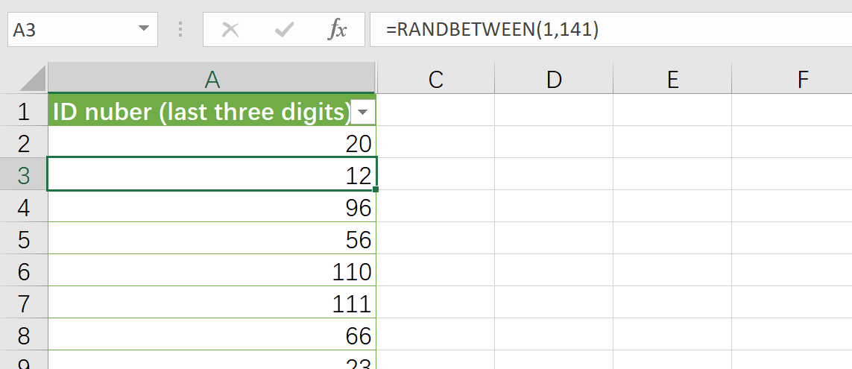

And drag it down to over thousand to make sure that there are enough numbers.

Then to make sure the numbers do not repeat, click the black arrow when hovering over the top of the table to select the whole table, and then copy it and paste it with values only (do not include the formula because that changes all the time!). Now it looks like this:

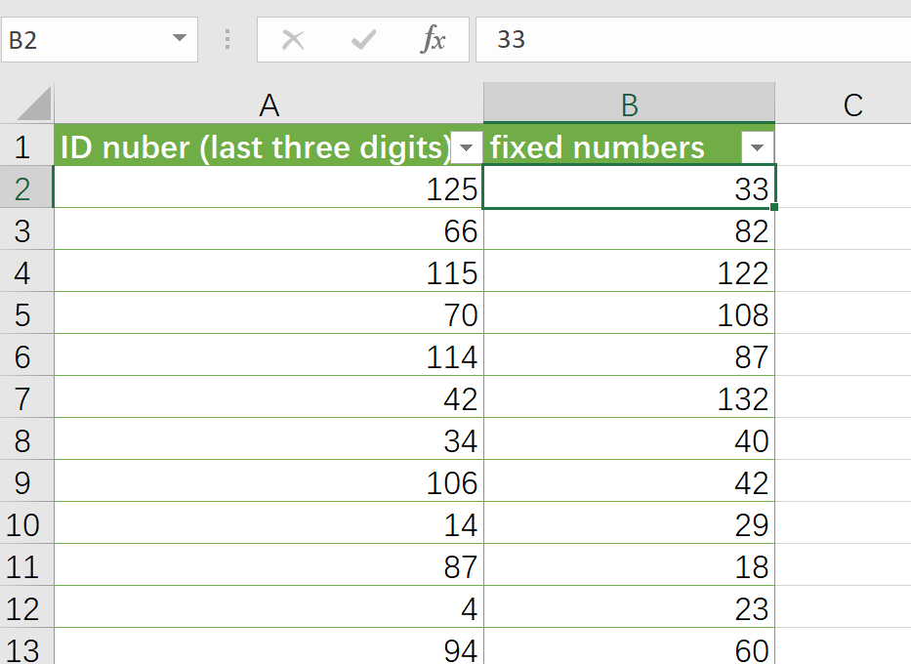

Next, select the new table, go to “design” and click on “Remove Duplicates”.

Now there should be a list of over 141 numbers from 001 to 141 without repetition.

1. Chose the first 103 numbers in the new table and find the corresponding names and school email addresses to be the sample by selecting the repeated value:

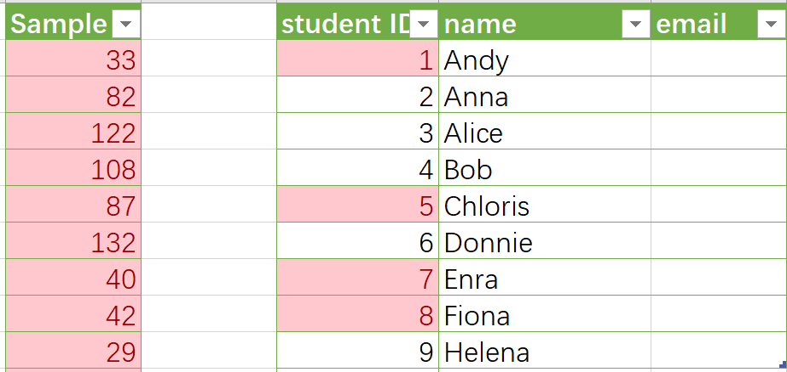

Select the two tables and choose the “Conditional formatting” in “Home”, and it will highlight the numbers appears in the sample, so all the samples can be easily determined.

All this is **on account of** the following reasons:

1. A separate analysis of each stratum can be done and comparison can be made between each group by using stratified sampling.
2. Sampling error will be reduced, because a sample that is proportional to the population can be obtained, and the whole population can then be well represented.
3. Every student has an equal chance of being selected, because the sample is proportional, and the sample selection in each stratum uses SRS.
4. Excel is a really convenient tool for sampling when dealing with many numbers.

However, **limitations** do exist in this method of sampling:

1. The sampling is not appropriate since not the probability of being selected for FP and DP1 are different because their parameters differ.
2. There are chances that many students from the same group may be chosen while no one in other groups are chosen, since there are no strata for different groups even though there may be big difference between groups.

# Procedure

### Prenotification Emails:

A prenotification email will be sent three days before the survey to each individual in the sample.

The email will include:

* The aim of the survey
* Incentive for the students
* Deadlines for submitting.
* How the survey will be done (Anonymous)
* Contact for any questions

The reason for all that information is to help eliminate nonresponse bias and reduce response bias:

* Knowing the aim of the survey helps reduce nonresponse bias because students know that the survey is related to themselves and next FP and DP1 students, so they will be more responsible and more likely to fill out the survey carefully.
* Incentive may also help reduce nonresponse bias. Since only part of the population are required to fill out the survey, incentives like candies or cookies for rewards may make it fairer.
* Deadlines are needed because we want to collect all the data in time, and punishment may also be included here for those who do not respond in time, for example, more probability to fail the whole Project Week.
* Stating that the whole survey is anonymous helps to reduce response bias. Also, it will explain that the email address is needed to keep record of who has done the survey.
* At last, contact for questions is needed for fear that some students may not respond because they do not fully understand the process.
* A prenotification may be helpful to attach more importance to this survey, so more students may fill it out and nonresponse bias will be minimized.

### Questionnaire

*All the numbers in the bracket mean justification at the end of this part.

*The words in blue are just explanations and are not included in the real questionnaire that the students can see.

*Here is the questionnaire:

**Survey on Project Week 2018** (1)

In order to help us school leaders to learn more about your experiences and growth during Project Week, and thus help improve the Project Week in the next year, we would like to invite you to spend five minutes completing this short survey. (2)

The survey consists evaluation and self-reflection. Those with * means required questions

The progress bar here shows how much you have done the survey (3):

**Basic Information** (4)

1. What grade are you in? *

FP DP1

1. School email address: @uwcchina.org*

Notice: the email address is just for us to register that you did the survey. The survey is anonymous and all the information you provide in this survey will not leak out.

**Evaluation & Reflection**

1. How well did you prepare for the classes for Siyuan kids? (from 1 to 5, 1 means not prepared, 5 means fully prepared) * (5)

1 2 3 4 5

1. What do you think is most meaningful part of Project Week 2018? * (6)

* Helping others
* Self-improvement
* Making friends
* Spreading UWC values
* It’s meaningless to me
* Others (please specify)

1. What is your worst experience? * (7)

* School agenda
* Accommodation
* Teaching is hard
* Environment
* Communication difficulty
* No bad experience
* Others (please specify)

1. Do you enjoy your overall experience in Siyuan School? (from 1 to 5, 1 means unsatisfactory, 5 means satisfactory)? * (8)

1 2 3 4 5

1. What existing problems or phenomena do you find during Project Week? (can be in any aspect) (9)

1. Do you have any advice on Project Week 2019? (10)

#### Reasons:

1. The survey has 6 questions, which is relatively **short**. Only the most useful ones about **different aspects** are included to make sure that no one give up half way because it’s too long.

Moreover, the questions are of different **formats** including categorical questions like multiple choice, ordinal questions, and textbox (Beadell)[3]. So, the students won’t feel too bored when doing it or just simply select a random answer.

Thus, **nonresponse bias** or **response bias** may be avoided.

1. Thepurposeof the survey and how long it takes is included here again to let the students have an overall view of what is happening here.
2. The progress bar here always stays on the screen as the questions go on so that people won’t feel they are at a lost and don’t know how long they will spend on this, so knowing that helps reduce **nonresponse** bias or only responding half of the questions.
3. The questions are **organized** **in order** in different parts so the students may feel more comfortable when follow the questions so they are more likely to finish the survey.
4. The answer to the question actually reveals how serious you treat Project Week 2018.
5. This question can tell us what is well done in Project Week 2018, so that we can continue
6. The question asks about the opposite of Question 6, and with the answer of this question, we will know what should be improved next year.
7. This a general question. It is placed near the end because that will be easier for the students since they have done the preceding part.
8. This question investigates on what the students learned and whether they thought and reflect a lot during Project Week.

#### Limitations:

1. The multiple-choice questions may not include all the answers.
2. The designer of the questionnaire went to only one place, and do not know all the details in other groups, so the questions may not include all aspects.
3. There are only a few open questions due to the large sample size, so we cannot get everyone’s individual feelings and thoughts.
4. The last two questions are optional. Students may be least willing to answer any questions in the end, so there must be **voluntary response bias**, but if they are also required questions, not only may students be forces to give irresponsible answers, but also we need to spend a lot of time and energy to collect and analyze all the answers. Thus, there is always a dilemma for this question.

### Delivering Questionnaire

To make sure everyone chosen does the survey, the survey will be done under advisors’ supervision during advisory meeting on Wednesday. The survey will be sent in advance to both advisors’ and the students’ emails.

### Collecting Responses

The results will be collected automatically online since online survey is used.

The responses will be collected during Wednesday’s advisory meeting. Those who do not respond after check on that Wednesday will receive an email for reminding and the prenotification letter will be resent. The deadline will be Thursday 21:00. For those who do not answer, actions will be taken for warning.

# Data analysis

There are two kinds of data collected in the survey: categorical and numerical. I will discussion the analysis of each kind individually.

### Numerical Data

##### Ordinal questions (Q1&4)

The answers are recorded in a table, then the relative frequency of each datum is calculated and charts are plotted for comparison between FP and DP1, and scores from 1 to 5. Here is an example:

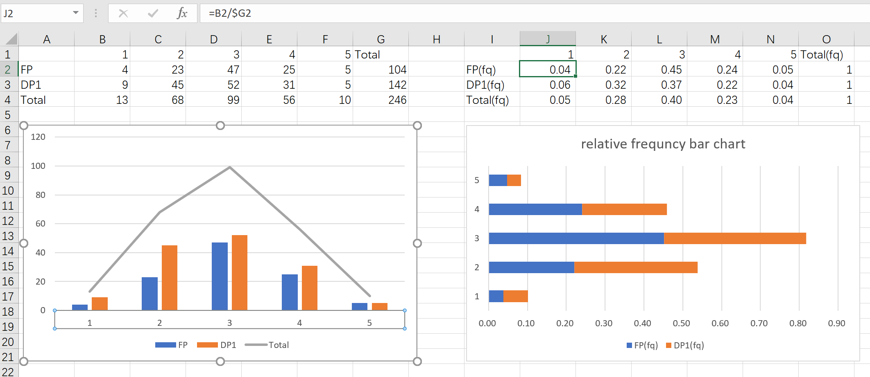

The **reason** for calculating the relative frequency is that the population size for two strata is different, but relative frequency can make the comparison possible.

The reason for choosing this kind of graph is that is not only visualizes the result but also make it easier to compare FP and DP1, and the overall trend in the results.

If the graph on the left tends to be normally distributed, i.e. bell shaped, that means the feedback is neutral; if the graph is positively skewed, that means the feedback is negative and some modification and improvement should be made; vice versa.

However, limitations still exist due to sampling error.

### Categorical Data

##### Multiple choice questions (Q2&3)

The analysis of data collected from multiple choice questions are similar to that from numerical data. Here is a possible example:

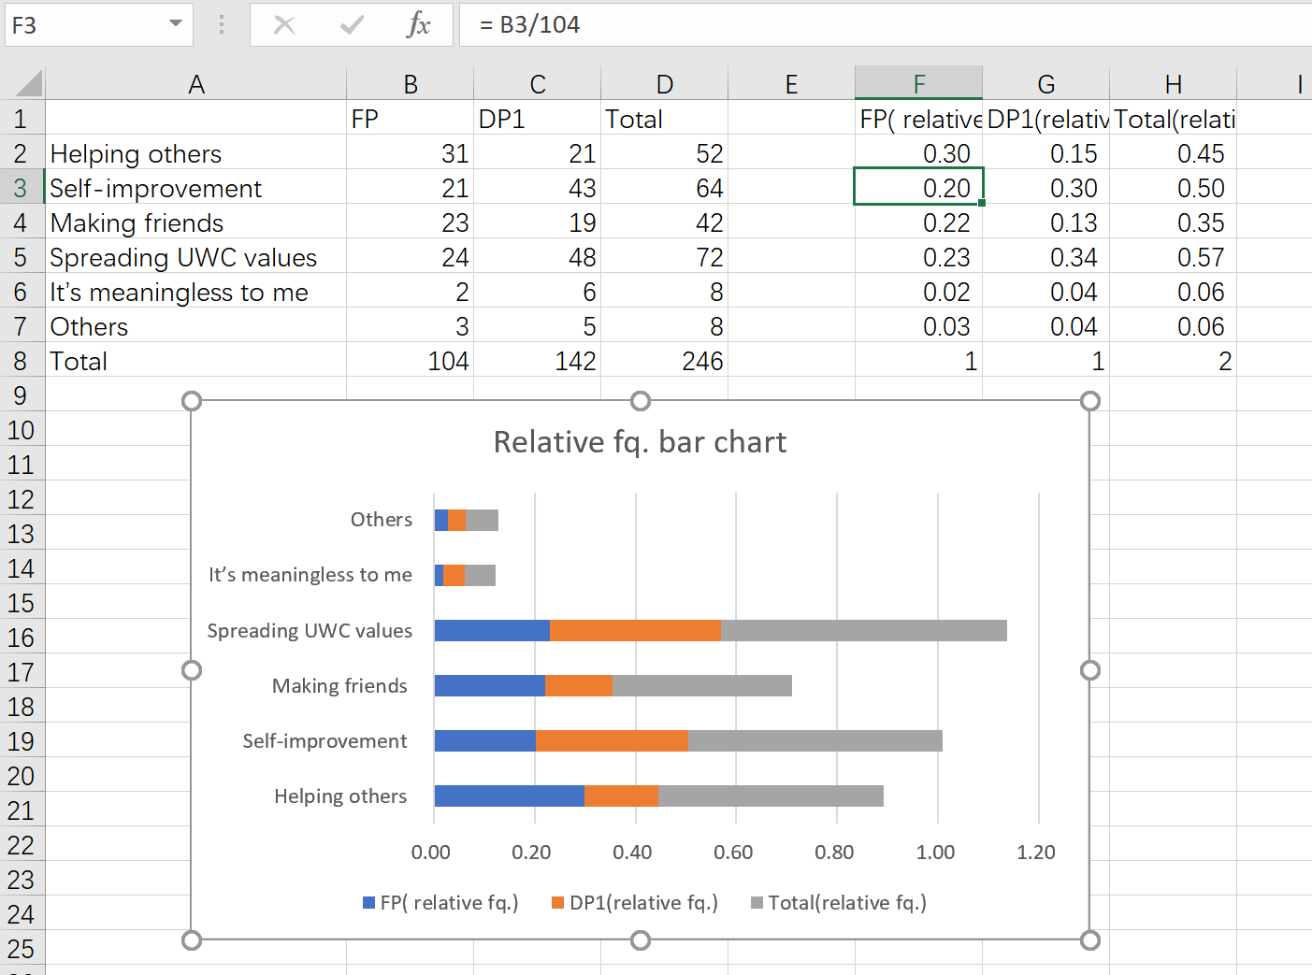

Moreover, we can also use a pie chart to show the proportion of each choice:

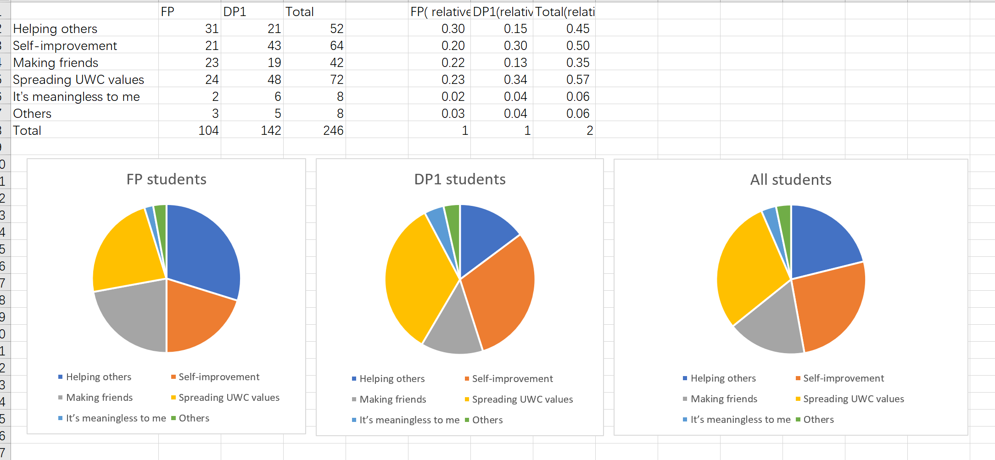

##### Open questions (Q5&6)

The answers from open questions will be grouped into different categories for analysis.

Then the analysis will be similar to that of the multiple-choice questions.

Nevertheless, limitations are that there is voluntary response bias since the open questions are not required questions. Also, some answers may be hard to be grouped in a certain category.

# Conclusion

### A list of report to Tingting

* The random sampling plan-multistage sampling
* How the questionnaire will be delivered
* The prenotification letter
* The questionnaire
* How the data will be collected
* How the results will be analyzed

In this survey, the aim was to learn more about UWC students’ gains during Project Week 2018 and thus improve the Project Week for the next year to give more benefits to the students.

The sampling methodology is multistage sampling, which ensures both randomness, comparison, and precision. The survey is conducted in a careful way in order to avoid all possible bias and try to minimize the sampling error by various methods.

The data will be analyzed in detail and provide useful information to help achieve the goal of the whole survey.

### Reference:

“Sample Size Calculator.” Statistical Language - Measures of Central Tendency, Australia’s National Statistical Agency, 30 Aug. 2018, www.abs.gov.au/websitedbs/D3310114.nsf/home/Sample+Size+Calculator.

2 Sullivan, Lisa. “Confidence Intervals.” SPH of Boston University, Boston University School of Public Health, sphweb.bumc.bu.edu/otlt/MPH-Modules/BS/BS704_Confidence_Intervals/BS704_Confidence_Intervals_print.html.

3 BEADELL, STEPHANIE. “Chapter 6: Surveys 101: A Simple Guide to Asking Effective Questions.”  [*The Ultimate Guide to Forms and Surveys*](https://zapier.com/learn/forms-surveys/)*, Zapier*, zapier.com/learn/forms-surveys/writing-effective-survey/.

variables affect the time of the pendulum swing: length of string and angle measure. The mass, however, does not

1. “Sample Size Calculator.” Statistical Language - Measures of Central Tendency, Australia’s National Statistical Agency, 30 Aug. 2018, www.abs.gov.au/websitedbs/D3310114.nsf/home/Sample+Size+Calculator.
2. Sullivan, Lisa. “Confidence Intervals.” SPH of Boston University, Boston University School of Public Health, sphweb.bumc.bu.edu/otlt/MPH-Modules/BS/BS704_Confidence_Intervals/BS704_Confidence_Intervals_print.html.
3. BEADELL, STEPHANIE. “Chapter 6: Surveys 101: A Simple Guide to Asking Effective Questions.”  [*The Ultimate Guide to Forms and Surveys*](https://zapier.com/learn/forms-surveys/)*, Zapier*, zapier.com/learn/forms-surveys/writing-effective-survey/.